EXPERIMENT-06
Aim: Implementing broadcast receivers. Design a broadcast receiver to respond to system or application-level broadcast. Test the receiver with different broadcast scenarios.
A Broadcast Receiver is an Android component that listens for broadcast messages sent by the Android system or other applications.
Theory:
A Broadcast Receiver is an Android component that listens for system or application-level broadcast messages. When a specific event occurs (like battery change or charger connected), the receiver automatically triggers the onReceive() method to perform an action.
- Create Project
  - Open Android Studio
  - Click New Project → Empty Activity
  - Select language: Java
- Create Broadcast Receiver Class
  - Right-click package → New → Java Class → MyReceiver
  - Extend BroadcastReceiver
  - Override onReceive() method
  - Show Toast message when broadcast is received
- Register Receiver
  - Open AndroidManifest.xml
● Add inside <application>:
<receiver android:name=".MyReceiver">
<intent-filter>
<action android:name="android.intent.action.ACTION_POWER_CONNECTED"/>
</intent-filter>
</receiver>
- Run Application
  - Connect emulator or device
  - Run the app
- Test Broadcast Scenarios
  - Power Connected
    - Plug charger → Toast message appears
  - Power Disconnected
    - Change action in Manifest:
<action android:name="android.intent.action.ACTION_POWER_DISCONNECTED"/>
  - Remove charger → Toast appears
Code:
MyReceiver.java
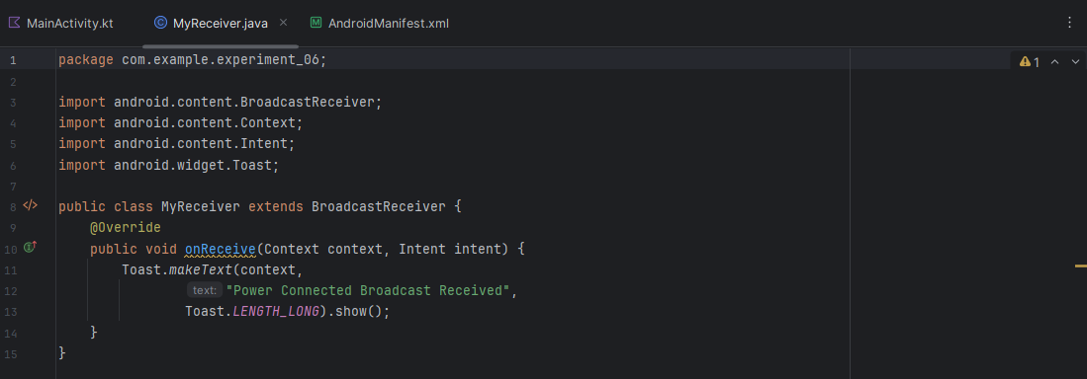

AndroidManifest.xml
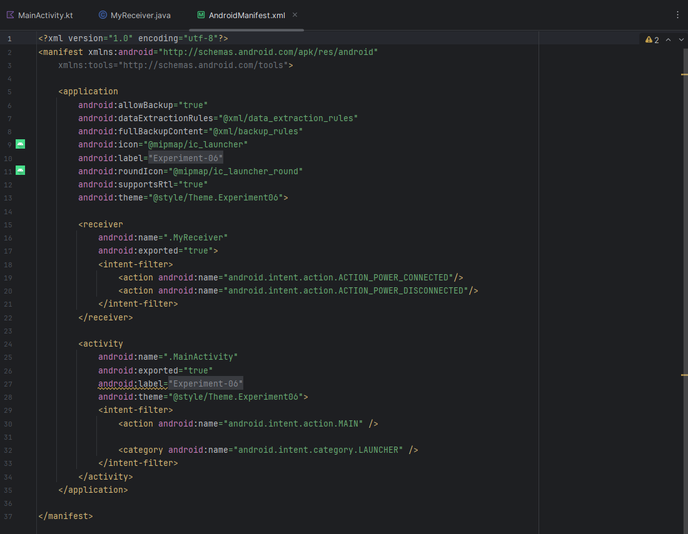

Output:
- System Broadcast Detection
  - App listens for system events like power connection
- Automatic Trigger
  - When event occurs, onReceive() is executed automatically
- Real-time Response
  - Displays Toast message when broadcast is received
- Different Scenarios
  - Works for multiple events:
○ Power connected
○ Power disconnected
- Background Functionality
  - Works even without user interaction
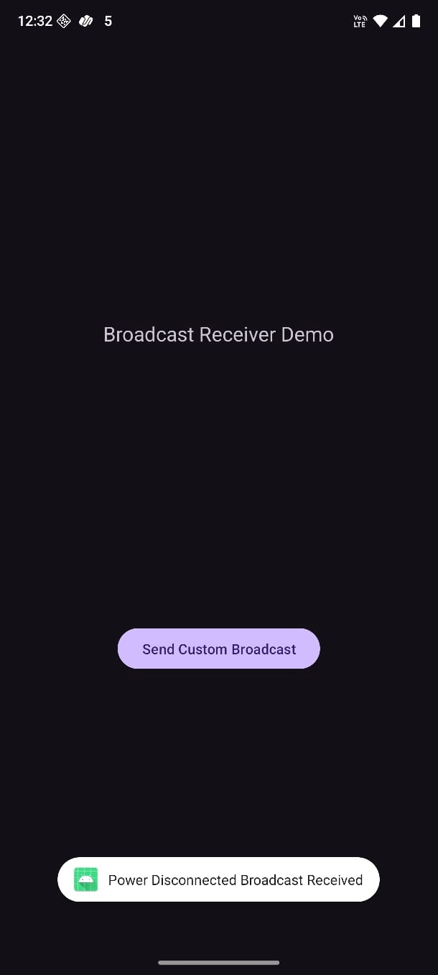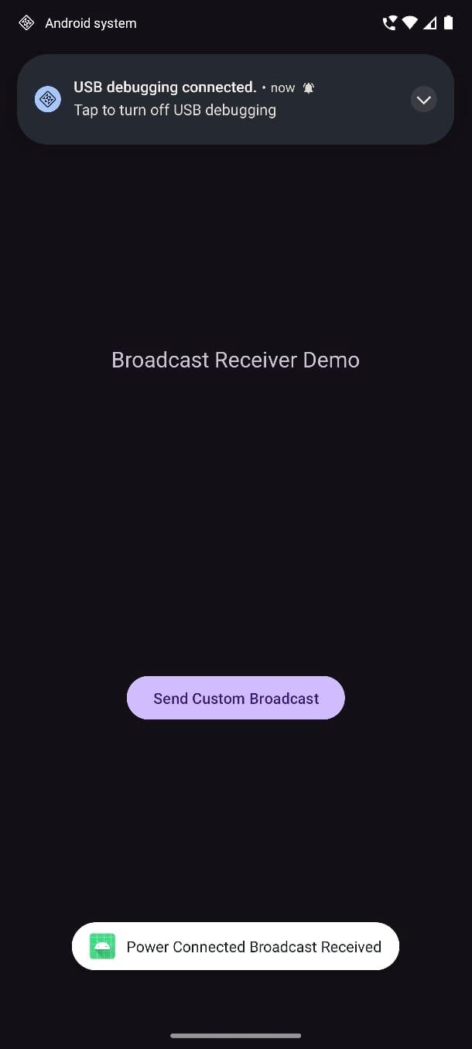
Conclusion:
This practical demonstrates how Broadcast Receivers handle system events and allow applications to respond automatically to changes in the device environment.

